
Amazon Interview Worksheet
INSIST ON THE HIGHEST STANDARDS
Definition and Indicators
Insist on the Highest Standards: Leaders have relentlessly high standards - many people may think these standards are unreasonably high. Leaders are continually raising the bar and drive their teams to deliver high quality products, services and processes. Leaders ensure that defects do not get sent down the line and that problems are fixed so they stay fixed.
What this looks like in Practice
As a people manager do you… | As an individual contributor do you…
- Raise the quality bar by demanding that your team delivers high quality products, services and solutions?  - Teach and coach employees about setting their own high standards and exceeding customer expectations?  - Provide feedback to employees when work is of high quality and coach to continually improve work? | - Ensure the quality bar remains high by delivering high quality work, and demanding it of others’ work?  - Continually self-critique your work to make sure the quality is the best it can be?  - Accept and seek out coaching and feedback from your manager and others about improving the quality of your work?

Insist on the Highest Standards - Suggested Behavioral Interview Questions
For each question you choose, use a separate STAR Worksheet
Questions for (Manager) in parentheses

- Tell me about a time when you have been unsatisfied with the status quo. What did you do to change it? Were you successful?
- Tell me about a time you wouldn’t compromise on achieving a great outcome when others felt something was good enough. What was the situation?
- What measures have you personally put in place to ensure performance improvement targets and standards are achieved?
- Describe the most significant, continuous improvement project that you have led. What was the catalyst to this change and how did you go about it?
- Give me an example of a goal you’ve had where you wish you had done better. What was the goal and how could you have improved on it?
- Tell me about a time when you have worked to improve the quality of a product / service / solution that was already getting good customer feedback? Why did you think it needed continued improvement?
- Give an example where you refused to compromise your standards around quality/customer service, etc. Why did you feel so strongly about the situation? What were the consequences? The result?
- How do you seek out feedback on your team’s performance? Give a specific example of how you used feedback you received on your team to drive improvement. (Manager)
- Can you tell me about a time when a team member was not being as productive as you needed? What was the situation? What did you do? What was the result? (Manager)
- Describe the process you go through to set specific targets to improve critical areas of your work/team. Please refer to a specific example. (Manager)

STAR WORKSHEET
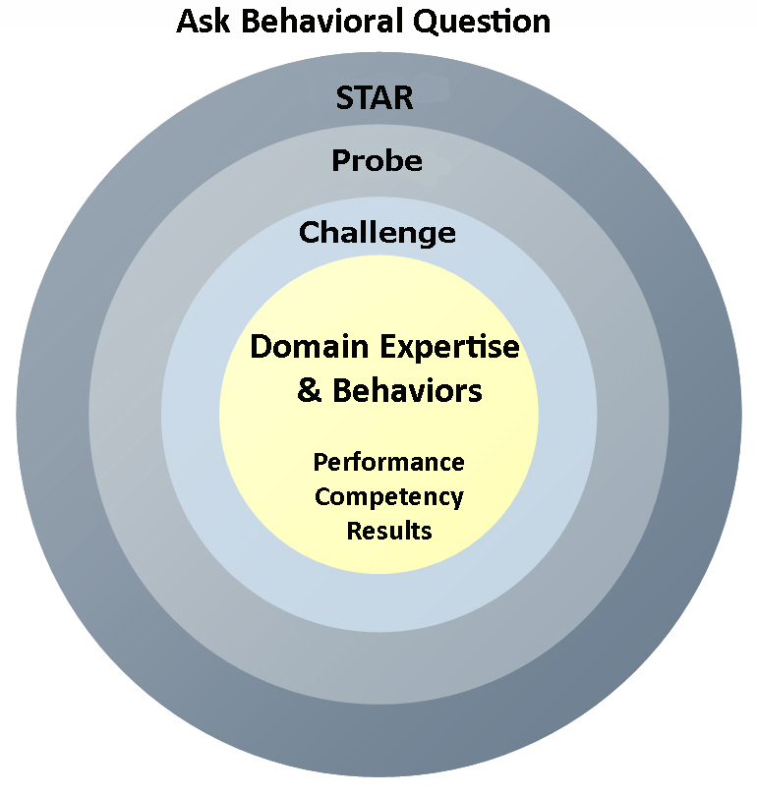
Your Behavioral Question:___________________________________________________________________Leadership Principle:_________________

- Choose behavioral question that provoke specific examples or stories for your assigned Leadership Principle(s).
- Process the example using STAR. Stories have beginnings (Situation/Task), middles (Actions) and ends (Results).
- Once you have established the story, PROBE to dive deeper on your assigned competency (Leadership Principle), get clarity or pursue a concern.
- If appropriate, CHALLENGE the candidate’s statements, decisions or thought process.
S  T | SITUATION/TASK - Describe the situation/task you faced and the context of the story  Answers the questions: where did this occur, when did it happen, why is it important?  Probing Questions:  - Why is this important? What was the goal?  - What was the initial scope of the project? What were the challenges?  - What were the risks and potential consequences if nothing happened?  Challenge Questions:  - Why did you choose this story to illustrate a xyz accomplishment?  - What other stories can you think of that demonstrate.. xyz?  - Could you come up with an example that is more recent? | Notes
A | ACTION - What actions did you take?  Answers the questions: what did you personally own, how did you do it, who else was involved?  Probing Questions:  - Deep probe functional expertise and/or assigned core competency.  - Were you the key driver or project owner?  - What was your biggest contribution? What unique value did you bring?  - What were the most significant obstacles you faced? How did you overcome them?  Challenge Questions:  - What did you do specifically versus the team?  - How did you set priorities…deal with xyz problem… or get manager buy-in?  - What decisions did you challenge? Why? How did you influence the right outcome?
R | RESULTS - How did you measure success for this project? What results did you achieve?  $ Cost savings, revenue generation  # Quantify to understand volume, size, scale  % Percentage change, year over year improvements  Time to market, implementation time, time savings  Impact on the customer, the team  δ Quality improvements  Probing Questions:  - Why did you choose to focus on these results? What other results were important?  - You mentioned revenue, what percentage change is that year over year?  - What trade-offs did you have to make to achieve this? (quality, cost, time)  - I’m concerned about… (the time it took, the volume, the customer impact), tell me more…  Challenge Questions:  - What were the lessons learned? What would you have done differently?  - How would you implement this at Amazon?  - How did these results compare to your actual goals? (refer back to goal stated in Situation)

